**Screenshots:**

1. In Mac, the equivalent to ipconfig/release is to disable DHCP configuration manually in order to release the assigned IP address. At this step you can check if your interface has no longer an IP (for MAC, look for interface en0 or en1 and check that you have: inet 0.0.0.0 -your IP address-) by using the command “sudo ifconfig” :

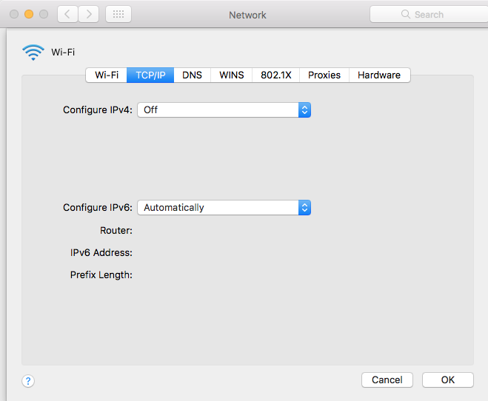

1. In order to do the ipconfig/renew, right after a release, you have to open the DHCP configured function again. At this step you should be able to see all DORA DHCP packets in Wireshark:

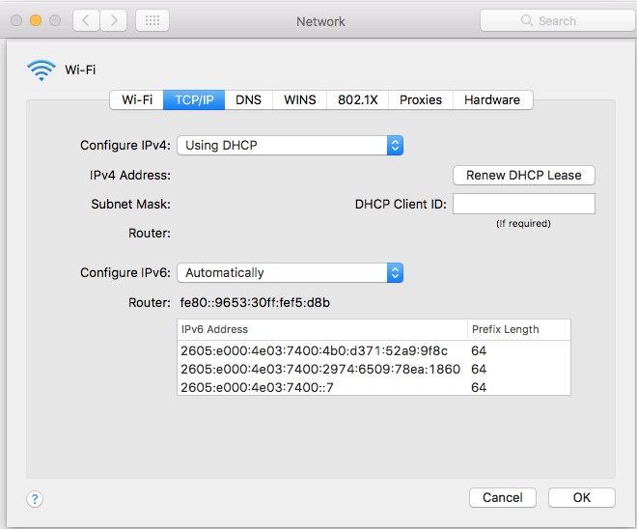

Again, you can check using sudo ifconfig that your interface is now associated to an IP address (same interface you found as inet 0.0.0.0 when you did the release).

1. To do the second renew requested in the lab steps you have to push the button “Renew DHCP Lease”, which is equal to renew the IP lease without release.

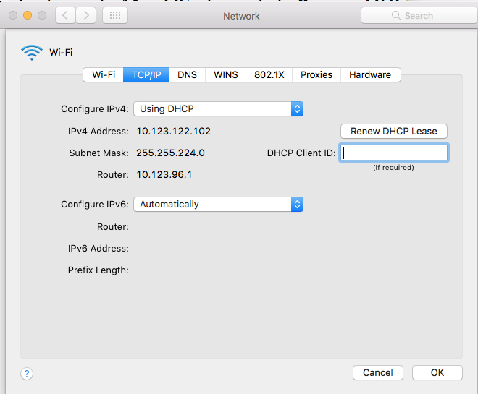

1. For the step 4, which is an ipconfig/release, just repeat step 1 in this guide.
2. For the final “ipconfig/renew”, just repeat step 2 in this guide, you should get all the DORA DHCP packets again.

Thanks to Pawat Vongchun for figuring out how to do Lab 1 using Mac OS